

Project Title:
Small Campus Network
Course:
Computer Networks
Group Members:
Sufyan Ghani 29
Faizan 04
Instructor:
Mr Bilal Ahmad
Class:
BS DS 4th

Department of Data Science
University of Kotli AJk

1. Abstract
This project focuses on designing a simple small-campus network using Cisco Packet Tracer. The network connects three departments Admin, IT, and Library using routers, switches, and PCs. The purpose is to understand IP addressing, device configuration, and inter-network communication.

2. Introduction
Computer networks play a vital role in communication and resource sharing within organizations. This project demonstrates the design of a small multi department campus network using Cisco Packet Tracer. The network consists of multiple LANs connected through a router, allowing devices in different departments to exchange information. Networking is essential in real world environments such as universities, companies, and offices to ensure smooth operations and secure communication. This project helps students understand practical network setup, device configuration, and the use of simulation tools for testing network behavior.

3. Objectives

- To understand how LAN communication works within a campus environment.
- To assign and configure IP addresses for all network devices.
- To connect and configure routers and switches for inter department communication.
- To perform connectivity testing using the ping command.
- To verify that all devices across different departments can successfully communicate.

4. Tools & Software Used

Tool | Software Version | Purpose
Cisco Packet Tracer | 8.0 | Networking simulation and configuration
Computer System | Any | Run simulation software
Networking Device | etc | Routers, Switches, and PCs used in topology

5. Network Topology
Topology Type
Star topology with Router-based Inter-LAN communication.

Small Campus Network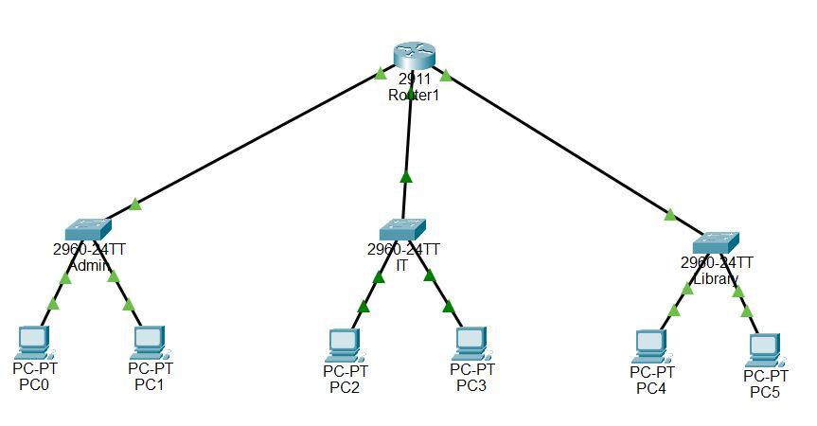
Fig 1
Example Description:
The network includes three switches connected to a central router, with two PCs connected to each switch. Each department has a separate IP subnet to ensure organized communication.

6. Device List
Device Name | Quantity | Purpose
Router(2911) | 1 | Interconnection all departmental network
Switch(2960) | 3 | Connects PCs each department
PCs | 6 | End user devices for communication

7. Implementation Steps
- Add Devices
- Add router, switches, and PCs in Packet Tracer.
- Arrange them according to campus departments.
- Connect Devices
- Connect PCs to switches using Straight-Through cables.
- Connect each switch to the router.
- Assign IP Addresses
- Admin Department (192.168.10.0/24)
- IT Department (192.168.20.0/24)
- Library Department (192.168.30.0/24)

Example PC configuration
- IP: 192.168.10.11
- Mask: 255.255.255.0
- Gateway: 192.168.10.1
- Configure Router
Example commands
enable
conf t
interface gig0/0
ip address 192.168.10.1
255.255.255.0
no shutdown

interface gig0/1
ip address 192.168.20.1
255.255.255.0
no shutdown

interface gig0/2
ip address 192.168.30.1
255.255.255.0
no shutdown

- Simulation & Testing
Use Command Prompt in PCs
Example:
ping 192.168.20.21
ping 192.168.30.31
Observation:
All devices successfully communicated across departments with no packet loss.
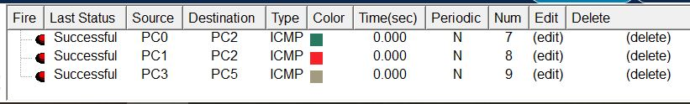

8. Results & Discussion
The campus network was successfully designed and implemented. Each department was assigned a unique subnet, and the router ensured communication between networks. Ping results confirmed full connectivity. A few challenges included selecting correct cables and configuring router interfaces, but these were resolved with proper understanding of device roles. The simulation helped visualize real-world network designs and improved understanding of IP subnetting and routing.

9. Conclusion
This project provided hands-on experience in designing a small campus network using Cisco Packet Tracer. It helped in learning how to assign IP addresses, configure routers, connect switches, and test communication between devices. The network showed efficient inter-department communication. Future improvements can include adding VLANs, DHCP servers, wireless access points, or firewall rules for better scalability and security.

10. References
Cisco Networking Academy Tutorials
Classroom Lecture Notes
Online networking resources and tutorials

11. GitHub Upload Project
